TBMI26 – Computer Assignment Reports
Reinforcement Learning
Deadline – 2019

Authors: Omkar Bhutra (omkbh878)
Jesper Lindberg (jesli060)

In order to pass the assignment you will need to answer the following questions and upload the document to LISAM. You will also need to upload all code in .m-file format. We will correct the reports continuously so feel free to send them as soon as possible. If you meet the deadline you will have the lab part of the course reported in LADOK together with the exam. If not, you’ll get the lab part reported during the re-exam period.

- Define the V- and Q-function given an optimal policy. Use equations and describe what they represent. (See lectures/classes)

Q-learning algorithm can train a system to perform the best action in a given situation.
Where r is the reward of doing the specific action in that state, V*(sk+1) is the value in the following state if the optimal policy is followed. This value function for the optimal policy is defined as V*(s)=max a Q(s,a).
Where, eta is the learning rate, gamma is the discount factor.

Optimal policy:
Let V*(s) denote the value function for the optimal policy.
Q(sk,a) = r(sk,a) +gamma* V*(sk+1)
Where,
V*(s) = max a Q(s,a)

Let V*(s) denote the value function for the optimal policy.
Q(sk,a) is the expected future reward of doing action a in state s and
then following the optimal policy.
Q(s,a) indirectly encodes the optimal policy and its value function V*(s)

Arbitrary policy:
Q(sk,aj) = (1-eta)*Q(sk,aj) +eta*(r + gamma* max a Q(sk+1,a))
V(s) = (1-eta)*V(s) + eta*(r + gamma*V(sk+1))

- Define a learning rule (equation) for the Q-function and describe how it works. (Theory, see lectures/classes)

Q(sk,aj) = (1-eta)*Q(sk,aj) +eta*(r + gamma* max a Q(sk+1,a)) --(1)

The Q-function is an instrument for experimentation around the best policies during learning.
Q(s,a) is the expected future reward for performing an action a in state s and then following an optimal policy:
Q(sk,a) = r(sk,a)+gamma X V*(sk+1)

The Q-learning algorithm:
Initialise a look up table for Q(s,a) with random values.
for each episode
initialise a start state s
repeat for each step k in the episode
choose an action aj
take action aj and observe reward r and next state sk+1
update the estimated q-function as defined in (1)
end
end

- Briefly describe your implementation, especially how you hinder the robot from exiting through the borders of a world.

The q-function is taken as a 3D matrix with the size of the gridworld as the x and y dimensions and the corresponding rewards are placed in the z axis. The valid options for action are up,down,right and left. Therefore, the q-function look up table is 10x15x4.
Negative feedbacks are given as rewards. A good action has a low negative reward and a bad action has a high negative reward. This is done so that the robot does not get into patterns of loops and those that don’t lead to the target.
The lookup table is initialized with 0’s such that all actions are equally weighted. The reward for actions leading to outside the boundaries of the gridworld are set to negative infinity (-inf) to make sure the robot does not get stuck at the boundaries of the gridworld for a long run of episodes, setting it to -inf will make the policy converge faster.
In order to have the robot explore unknown territory, the epsilon parameter is adjusted which is the probability of the robot to make a random action. This might lead to a better solution than the policy which is already known. Best actions are based on the V*(s) function, the action with the highest reward magnitude. The probability to make this optimal action is (1-epsilon) while the probability to make a random action is epsilon. The value of epsilon is high in the beginning to explore new regions and the q-function is updated with each step according to the arbitrary policy equation.

- Describe World 1. What is the goal of the reinforcement learning in this world? What parameters did you use to solve this world? Plot the policy and the V-function.
The first world is a static world where the obstacles and goal remains the same.
By Varying iterations (gamma=0.9, epsilon = 0.95, epsilondecay = 0.998 and eta = 0.5) High exploration rate and a very small exploration decay seem to work well in converging to solutions quickly and take care of the obstacle.

n_iterations = 100 n_iterations = 200

n_iterations = 300

It is observed that increasing the numbers of episodes is not changing the solutions drastically but is solving few head on collisions.

By varying the learning rate (gamma = 0.9, epsilon = 0.95, epsilondecay = 0.998)

n_episodes = 100 , eta = 0.2

n_episodes = 100 , eta = 0.5

n_episodes = 100 , eta = 0.7

It is observed that increasing the learning rate is improving the policy

To goal of reinforcement learning in this world 1 is to find the best V*(s) solution. To solve this world, a high exploration rate is used .We use random initialization, by using a larger epsilon value, the probability of making a random action (epsilon) , More exploration is performed, the solution gets better but the bot uses less of the learnt knowledge as it is set to explore more. This is the exploration-exploitation tradeoff. A high learning rate can be used for world 1 since it is deterministic.

n_iterations = 300, eta = 0.99, epsilon = 0.95, epsilonDecay = 0.998

- Describe World 2. What is the goal of the reinforcement learning in this world? What parameters did you use to solve this world? Plot the policy and the V-function.
World 2 is dynamic and our goal for the robot is to adapt to the changing environment. Sometimes there is a blob which has a reward lower than usual, ‘ the irritating blob’. The algorithm in this case avoids passing through this blob even when it does not show up in the particular case. Using a high learning rate is not a good idea in this world since the randomness of the environment will be forgotten soon.
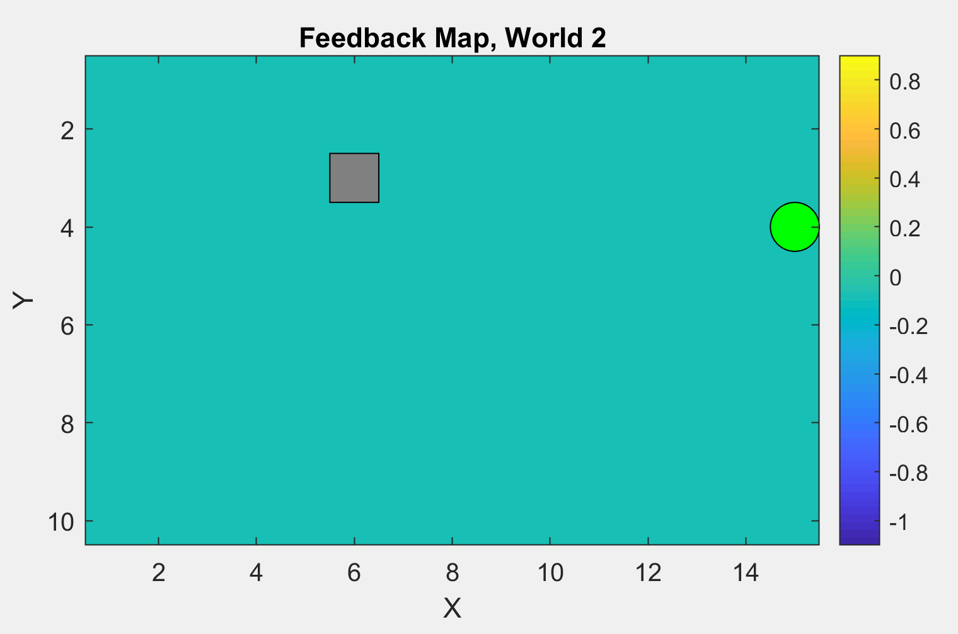

World 2 without the blob, the blob appears at random at some iterations. A long term reward focus and high exploration rates through all episodes along with low learning rate I used.

eta = 0.15 , gamma = 0.9 , epsilon = 0.95 , n_iterations = 200 and small epsilondecay of 0.998
- Describe World 3. What is the goal of the reinforcement learning in this world? What parameters did you use to solve this world? Plot the policy and the V-function.
World’s 3 and 4 have similar topology of the safe routes and obstacles encountered. There exists 2 large horizontal obstacles with a safe route between them which is the shortest to the goal in this case. Colliding arrows exist on the top of the map , maybe due to less exploration as the safe route between obstacles is the short path.

n_iterations = 1000 , eta = 0.5, epsilon = 1, epsilonDecay = 0.996 and gamma = 0.9

- Describe World 4. What is the goal of the reinforcement learning in this world? How is this world different from world 3, and why can this be solved using reinforcement learning? What parameters did you use to solve this world? Plot the policy and the V-function.

World number 4 is similar to world 3 but the start and goal points are swapped in this case.

Learning in these gridworld simulates a visit to HG(bar) in world 3 and return from HG(bar) in world 4. Where the drunk robot cannot find the shortest path. This may be due the fact that the the shortest path exists in a straight line in world 3 while in world 4 the shortest path involves a left turn at the very beginning.

n_iterations=100,gamma = 0.7;epsilon = 0.9;epsilonDecay = 0.996;eta = 0.8;
The discount factor was reduced and the learning rate was increased compared to the previous map to focus slightly more on the short term reward and include more new information during learning. The iterations seem insufficient to converge to a decent solution.

The bot learns to avoid the alley due to risk of slipping out in to the danger region.
n_iterations = 200, gamma = 0.7, epsilon = 0.9, epsilonDecay = 0.996, eta = 0.8

n_iterations=500, gamma = 0.9 ;epsilon = 0.9;epsilonDecay = 0.998;eta = 0.6;

The discount factor and learning rate need to be changed to converge to a better solution. More iterations may be required for a clear path solution to converge.
The final solution of gridworld 4:

n_iterations=2000, gamma = 0.99;epsilon = 0.9;epsilonDecay = 0.998;eta = 0.2
A large number of iterations, discount factor increased to focus maximum on long term rewards, epsilon is reduced rapidly with time to increase the convergence of the solution and there is more focus on learned experience and hence eta is reduced.
It shows that learned experience takes the bot away from the dangerous alleyway and around the borders to a safe path albeit a long one.

- Explain how the learning rate α influences the policy and V-function in each world. Use figures to make your point.

World 1; 300 iterations, gamma=0.9,epsilon = 0.99,
EpsilonDecay = 0.998, eta(alpha) = 0.2

Eta(alpha) = 0.5 , keeping remaining parameter’s the same.

Eta(alpha) = 0.7 , keeping remaining parameter’s the same.

Eta(alpha) = 0.9 , keeping remaining parameter’s the same.

The significance of learning rate can be studied with the example of world 1. The alpha(eta) value when kept low or when it is close to 0 then the algorithm focuses on learned experience or previous good moves made. When the alpha(eta) value is kept high or when it is close to 1 then the algorithm focuses on new information and can overwrite previous experiences with it. It is observed that the obstacle region is clearly handled as the learning rate goes up, more parallel patterns of solution paths are also formed with the learning rate going up. Although the shortest path is found with the lower learning rate.
- Explain how the discount factor γ influences the policy and V-function in each world. Use figures to make your point.

Gamma = 0.3 , n_episodes = 300, epsilon = 0.99 , epsilonDecay = 0.998 and eta = 0.2

World no. 4 is chosen for this illustration as there is a clear difference of solution for short term rewards vs long term rewards. From our previous runs on world 4, we know that a lower learning rate was required, solution got better as the discount factor went up. In this world, any focus on short term reward leads the bot into the alley but fails to converge into a proper solution as the bot learns to avoid the alley due to risk of slipping out.

Gamma = 0.6 , n_episodes = 300, epsilon = 0.99 , epsilonDecay = 0.998 and eta = 0.5

Gamma = 0.99 , n_episodes = 300, epsilon = 0.99 , epsilonDecay = 0.998 and eta = 0.5

As the focus on long term rewards is maximized i.e the discount factor is pushed to higher limits, then the algorithm decides to take the longer route around the obstacles as the optimal action and a clear solution is plotted.

- Explain how the exploration rate ε influences the policy and V-function in each world. Use figures to make your point. Did you use any strategy for changing ε during training?

Navigation of the exploration factor or epsilon is done using another parameter called exploration factor decay rate or epsilon decay. This is done to turn the algorithm from explorative mode to exploitation over time as the algorithm learns the good moves that work.

World no.5 as the exploration factor is reduced from 0.95 to 0.5 to 0.3 with the decay kept constant at 0.998.
It is noticed that when the epsilon is high the bot tends to take more turns i.e it is exploring the map while the bot tends to take more learned paths in straight lines once the exploration rate becomes close to exploitation.
Exploration factor effect on flat world.

- What would happen if we instead of reinforcement learning were to use Dijkstra's cheapest path finding algorithm in the ''Suddenly Irritating blob'' world? What about in the static ''Irritating blob'' world?

Dijkstra’s pathfinding algorithm finds the cheapest possible path , i.e if it succeeds in finding a path. Although, the noise induced as is in the case of the suddenly irritating blob could cause the algorithm to fail. Static grid worlds such as the world number 1 (irritating blob) should be successfully navigated using dijkstra’s shortest path finding algorithm.

- Can you think of any application where reinforcement learning could be of practical use? A hint is to use the Internet.
Reinforcement learning is used to determine the ideal behavior within a specific context, in order to maximize its performance. Unlike supervised learning, large amounts of labeled data with the correct input output pairs are not explicitly presented.
A clear case of use would be computer games where a scoring system or goal is present which can be used as a component in a reward function and can be split into well defined states.
Manufacturing , Inventory management where robots use reinforcement learning to actuate the effectors accurately.
Finance sector where reinforcement learning can be used to train and use bots to create winning trading strategies.
- (Optional) Try your implementation in the other available worlds 5-12. Does it work in all of them, or did you encounter any problems, and in that case how would you solve them?
World no.5 as the exploration factor is reduced from 0.9 to 0.5 to 0.3 with the decay kept constant at 0.99.

Exploration factor effect on flat world.

Navigation of the exploration factor or epsilon is done using another parameter called exploration factor decay rate or epsilon decay. This is done to turn the algorithm from explorative mode to exploitation over time as the algorithm learns the good moves that work.

n_iterations = 500, gamma = 0.9, epsilon = 0.9, epsilondecay = 0.99 and eta = 0.5.

n_iterations = 500, gamma = 0.9, epsilon = 0.7, epsilondecay = 0.99 and eta = 0.5

n_iterations = 500, gamma = 0.9, epsilon = 0.5, epsilondecay = 0.99 and eta = 0.5

